Application Form

Lead author

Name:

Rafael Monge-Vargas

Agency/institution:

Centro Nacional de Información Geo-Ambiental (CENIGA), Costa Rica

Mailing address:
Barrio Francisco Peralta, Calle 25 A, entre Avenidas 10 y 8. San José, San José, Costa Rica.

Email:
rmonge@minae.go.cr

Phone:
+506 2233-4533 ext. 1213

GEO-Amazon Earth Observation Cloud Credits Programme: A Global Modeling Tool for Nature’s Contributions to People in Sustainable Development

Lead Investigator
Rafael Monge Vargas, Ministry of Environment and Energy, Costa Rica, rmonge@minae.go.cr

Key Stakeholders
Irene Alvarado Quesada, Central Bank of Costa Rica, alvaradoqi@bccr.fi.cr
Glenn-Marie Lange, The World Bank, glange1@worldbank.org

Collaborators
Rebecca Chaplin-Kramer, Natural Capital Project, Stanford University bchaplin@stanford.edu
Richard Sharp, Natural Capital Project, Stanford University bchaplin@stanford.edu
Steve Polaksy, University of Minnesota, polasky@umn.edu
GEOBON Working Group on Ecosystem Services
Anna Cord, Helmholz University / UFZ, Germany anna.cord@ufz.de
GEOBON Director
Henrique Pereira, iDiv, Leipzig, Germany - hpereira@idiv.de

Executive Summary
In late 2020, the UN Convention on Biological Diversity (CBD) will convene nations to set new targets under the ‘Post-2020 Biodiversity Framework.’ This framework will guide conservation action and investment for the next decade, including hundreds of millions of dollars invested in conservation by nearly 200 countries, and for the first time CBD targets will aim to explicitly integrate the UN Sustainable Development Goals (SDGs). At the same time, several other international policy windows are opening through 2020 to galvanize sustainable development, yet there is currently no agreed-upon, science-based approach to identifying the natural capital needed to support humanity and achieve the SDGs. We aim to provide the first ever global maps of ‘critical natural capital’, ecosystems providing benefits that are not easily replaced, particularly for the world’s most vulnerable people, building on recent advances in global modeling of ecosystem services, enhanced with new social data on human dependency, and synthesize these disparate indicators to inform global policy targets. As a global leader in sustainability, Costa Rica is well poised to lead an innovative international partnership to create new decision-support tools for sustainable development. Our Central Bank and Ministry of Environment and Energy is working with Stanford University to develop new platforms for Earth Observation data and ecosystem services modeling to enter into decision-making on natural resources through the SDGs, UN’s System of Environmental Economics Accounts, and the World Bank’s inclusive wealth accounting. To gain the broadest possible scientific and policy audience, we will serve and share these global maps of critical natural capital, the downscaled modeling efforts in Costa Rica and ultimately in other countries leading sustainability commitments, and the co-developed cloud computing tools for setting sustainable development strategy.

Project Plan

Background and Motivation

The global biodiversity and human development agendas for beyond 2020 are culminating in several key moments in the next few years: the UN Convention on Biological Diversity (CBD) 15th Conference of Parties that will set new targets under the “Post-2020 Biodiversity Framework” in late 2020; policy and finance agreements will be discussed at the World Economic Forum in the coming years to operationalize commitments made at the Sustainable Development Summit in 2018; the Global Environment Facility (GEF) announced the 7th replenishment round of investment for member countries in June 2018, highlighting natural capital approaches for informing lending decisions; all leading up to Rio +30 in 2022, where new commitments will be made to sustainable development. These present key opportunities for information about the current state of natural capital, and predicted impacts of changes in policy, land-use and climate on human well-being to guide the global sustainable development agenda.

Two broad decision contexts are ripe for engagement on natural capital right now. 1) In the long term, the World Economic Forum and multi-laterals are poised to transform sustainable development through investment decisions informed by natural capital approaches. 2) In the nearer term, the Conference of Parties determining the post-2020 CBD framework seeks to explicitly integrate the UN’s Sustainable Development Goals (SDGs). The SDG agenda recognizes that natural capital supports biodiversity and provides critical ecosystem services that underpin many of the goals, including those that do not explicitly refer to nature such as SDG 2 (zero hunger); SDG 6 (clean water and sanitation) and SDG 13 (climate action). If the connections between nature and human well-being are not accounted for, global development and human prosperity in the long-term will be compromised. Just as the global community converged on commitments and plans for confronting climate risks in Paris in 2016, we need a global consensus on securing the natural capital that is critical to sustaining life on the planet. However, there is currently no agreed-upon, science-based approach to setting global targets for biodiversity and ecosystem services, nor a means of identifying where, and how much, natural capital contributes to sustainable development at the national scale.

Recent developments have set the stage for filling this information gap through mapping and economic valuation of global ecosystem services, but rapid advances are needed in the next 18 months to answer the urgent need to connect the relevant science to SDG targets. The forthcoming IPBES Global Assessment has gathered more information on ecosystem services and nature’s contributions to people than has ever before been assembled, with several groups mapping historic, current, and future scenarios of provision of several ecosystem services. In the years since the Millennium Assessment, the last assessment of similar magnitude, there has been an explosion in both data and technological advances, enabling higher resolution modeling at broader scales. The Natural Capital Project (NatCap) at Stanford University has recently developed the data and computational infrastructure to represent highly spatially-dependent processes for services such as water purification, coastal storm mitigation, and pollination globally, as well as a framework for assessing the contribution of nature to the overall provision of these services (Figure 1).

Figure 1. From Chaplin-Kramer et al. “A Global Assessment of Nature’s Contributions to People and Humanity’s Need for Nature”, in review.
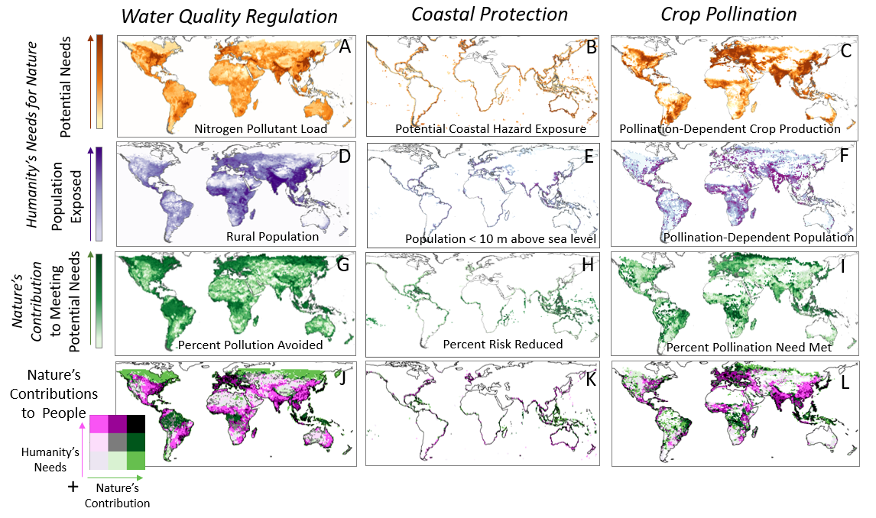

The alignment of recent scientific advances with key policy windows and demand for this information presents an important opportunity to galvanize the conservation and sustainable development communities, to build consensus and create replicable scientific approaches to inform world leaders, and to guide implementation of CBD targets and other international commitments to sustainable development. Stanford is developing an integrated framework and modeling approach for assessing the impacts of changes in policy, land-use and climate on the achievement of sustainable development, by linking nature’s contributions to people through both economic and non-monetary metrics. This is achieved by representing impacts of future changes in natural capital on people, through the mapping nature’s contributions to relevant populations (for example, the number of deaths, missing persons and directly affected persons attributed to disasters). These variables can be linked to individual SDG targets as a near term step and will produce a replicable approach in the longer term to guide lending decisions and policy to secure critical natural capital for achieving sustainable development.

Co-production of the approach with stakeholders and national and global scales

Testing the credibility of the spatial representation of ecosystem services provision and value is important at multiple scales of decision-making, to determine what types of decisions can be informed using global modeling and what requires replication of the approach at a national or local scale. The Natural Capital Project’s global approaches are being replicated our approach in 3 countries, based on consultation with GEF and other multilateral lenders (World Bank, Inter-American Development Bank, Asian Development Bank) and the opportunity to scale the impact beyond these pilot countries. This will result in the production nationally-relevant summaries of nature’s contributions to people and to achieving SDG goals or other commitments to sustainable development, to demonstrate the use of our approach in sustainable development planning at a national scale. These global outputs will be compared to local or national results to determine what aspects of information translate across scales, whether it can be used at a national scale to select priority places, the magnitude of difference in estimates of value, and overall best practices for the use of global information in decision-making.

Costa Rica, a GEO-member country, is the focus of the first of these downscaling modeling pilots. Costa Rica has been a global leader in environmental sustainability, pioneering the first national payments for ecosystem services program, recently declaring their commitment to carbon neutrality by 2050, and now piloting the world’s first national ecosystem services accounts through the United Nations System of Environmental Economic Accounting (SEEA) Experimental Ecosystem Accounting (EEA) framework. Our project team is currently funded through NASA’s GEO program to extend global modeling for ecosystem services to include new and better sources of satellite information as model inputs, to link ecosystem services modeling to GEO-BON’s Essential Biodiversity Variables (EBVs), and to provide cloud-based tools for Costa Rica’s Central Bank to use in these ecosystem service accounts. This supports the GEO work program to build capacity for monitoring and assessing EBVs and ecosystem services, and the tools created can also be co-hosted by GEO’s Bon-in-a-Box program.

Costa Rica’s National Center for Geo-Environmental Information (Centro Nacional de Información Geo-Ambiental, CENIGA), under the Ministry of Environment and Energy, is coordinating a consortium of Costa Rican actors within and outside the Ministry, co-designing the tools with the Natural Capital Project. CENIGA is the lead agency for environmental data production and processing in Costa Rica, in charge for the coordination of the National Environmental Information System (SINIA), which constitutes the national institutional platform for coordination, management and integration of environmental data and information.

Costa Rica was also part of the first core implementing countries for the World Bank’s Wealth Accounting and Valuation of Ecosystem Services (WAVES) program, and the Natural Capital Project is also currently working with staff at the World Bank to co-produce a Natural Capital Index, that will draw on much of this work.

One key actor CENIGA has brought into this consortium is Costa Rica’s Central Bank, who have helped identify four areas of opportunity, where natural capital information could improve decision-making for the national accounts for ecosystem services, and that could serve as an example for others to follow. These include:
1) Carbon: combining LiDAR and satellite data to develop a modeled relationship of biomass from satellite data that can be applied the whole country's extent, and then updated each year with new satellite imagery.
2) Tourism: integrating BCCR hotel information with social media data, including user tags of nature-related activities, to develop a spatial model to predict visitation rates from different ecosystem types and biodiversity
3) Water and/or natural disasters: developing a hydric balance tool utilizing satellite data to more frequently update hydrologic information, or potentially incorporating flood, landslide and/or coastal risk models to assess climate risks and asset values of habitat mitigating risk.
4) Pollination: modeling availability of pollinators based on species distribution models produced with satellite data on climate and satellites, and adjusting the national accounts on coffee yields dependent on pollination.

The interdisciplinary team we have assembled to conduct this work includes ecologists specializing in biodiversity and ecosystem services, hydrologists, remote-sensing specialists, economists, and computer scientists. Working closely with researchers within universities and also members of the Ministry, Central Bank, and World Bank, our team will achieve trans-disciplinary work that can reach across sectors and scales.

Technical specifications

Chaplin-Kramer et al.’s forthcoming, " Global Assessment of Nature’s Contributions to People and Humanity’s Need for Nature" (currently in review at Science, manuscript and supporting information available upon request) describes a conceptual and computational framework to model and predict humanity's reliance on nature. Specifically, three ecosystem services (nature's contribution to crop pollination, nutrient retention, and coastal protection) were modeled across four scenarios.

For each service, we consider: (i) a human component consisting of potential need based on physical pressures driving demand for benefits from nature and the population exposed to this need, jointly yielding humanity’s needs for acquiring benefits from nature and (ii) a biophysical component of nature’s contribution to meeting potential needs (as the proportion of potential needs that are met by nature).

The contribution that nature makes to meeting potential human needs is a function of the amount and configuration of habitat, as well as with other drivers and stressors placed on the natural system such as climate change or pollution from agricultural inputs. However, these biophysical measures indicating “potential need” for the service may or may not coincide with where and how much people depend on the benefits from nature, and thus the additional consideration of which populations are most dependent on nature’s role in delivering benefits is critical to establishing where these potential needs and nature’s contributions to meeting them matter to people (Fig 2).

Figure 2. Conceptual Framework for Nature’s Contributions to People
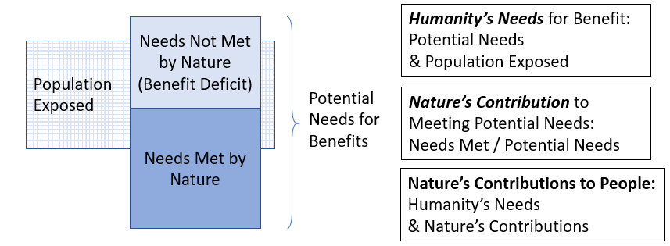

What nature provides to meet potential human need for benefits, which is often called an “ecosystem service” (but should be thought of as the potential supply of a service ) may be measured in terms of tons of pollutant retained, or kilometers of coastline protected, or number of people equivalents whose dietary requirements are met by pollination. We emphasize that a proportional representation of nature’s contribution to meeting potential needs is important to track differences or changes across space and time; as total measures of need met could increase alongside (or due to) a higher potential need (or higher demand for benefits of nature), nature’s relative biophysical contribution may remain the same. If pollutant load increases or climate change puts more coastline at risk or more pollination-dependent crops are grown, a constant proportional contribution of nature to meeting potential need would result in higher levels of corresponding pollution retention, storm risk mitigation and pollination. In this case, while a given benefit of nature may be seen to increase, nature’s contribution may remain unchanged due to a corresponding increase in potential needs for the benefits of nature. The relative contribution nature makes to meeting humanity´s needs, along with the needs of vulnerable people, are more useful metrics, as they reveal where and when nature plays a key role in delivering benefits.

We also examine the deficit of benefits people depend upon for their well-being (which could be met by nature, or to some extent by other capital assets, e.g., infrastructure), and the populations exposed to changes in that deficit for each NCP in future scenarios. We use nitrogen export (the amount not retained by vegetation that therefore enters waterways and drinking water supplies as pollution) as the deficit measure for water quality regulation, exposure to coastal hazards (remaining after the attenuation of storm surge by any coastal habitat) for coastal protection, and the amount of crop losses due to insufficiently pollinated crops for pollination. These deficits – drinking water pollution, coastal hazards, crop losses or food shortages—are the outcomes people will actually face and perceive, and what will determine people’s quality of life, the visible component of NCPs. They do not by themselves, however, reveal the role nature plays in contributing to that quality of life.
Each scenario/model pair uses free, open, multi-source Earth observation space data sources from NASA and the ESA, which requires several hundred gigabytes of digital storage space per run. Additionally, each simulation is computationally intensive requiring several hours of memory intensive computation time across parallel CPU cores. Results include high resolution (300m) global maps of ecosystem services value, aggregation to geographical and political units, and are available for direct download or interaction with an online visualization tool.

As part of a currently funded NASA project, we are modeling additional ecosystem services (carbon, tourism, water availability or timing or flood regulation), as well as a more feature-rich data visualization tool for initial use by the Central Bank. For carbon, we’re working toward combining LiDAR and satellite data to develop a modeled relationship of biomass from satellite data that can be applied the whole country's extent, and then updated each year with new satellite imagery. For tourism. we are developing a spatial model to predict visitation rates from different ecosystem types and biodiversity based on species distribution models and social media data, including user tags of nature-related activities. For water and/or natural disasters, we are developing a hydric balance tool utilizing satellite data to more frequently update hydrologic information, and exploring modeling for flood, landslide and/or coastal risk models to assess climate risks and asset values of habitat mitigating risk. We are also improving our model for pollination, testing various vegetation indices to move the InVEST model from LULC to EO-derived metrics of habitat complexity (as a surrogate for nesting and foraging resources).

For this project supported by Amazon Web Services, we will scale up these models tested within the Costa Rican context from the national scale to the globe, extending to international multilateral actors like the World Bank. It is with this previous experience and future plans that we estimate the following data and computational needs for a three year period:

- Compute Server at 16 cores and 96 GB of RAM operating at 50% uptime: this estimate is based on previous experiments where we found no extra benefit from additional cores nor ram so long as bandwidth to local data storage was saturated. In general, this kind of virtual machine can generate global results at 300m on a variety of models with a few hours, and smaller scales in minutes. This machine would be deactivated when not used for computing simulations, hence the 50% uptime estimate.

- A quad core 4GB RAM operating at 100% uptime: this server will be used to host an online map application to interact with results. The server will run a Python Flask web app and will need to be always-on.

- Local and long term data storage of 4TB: this is sufficient to model additional future ecosystem services as well as cache and host computed simulations.

- Network ingress and egress at 4TB per month: this accounts for additional intake of remote sensed data for future scenario runs as well as serving public model results.

An official Amazon AWS estimate is here: https://calculator.s3.amazonaws.com/index.html#r=IAD&s=EC2&key=calc-325DE667-19B1-42AA-A380-FB7093EFAC48

Data and software used and developed in the course of this project, along with any lessons learned or best practices, will be made fully and freely open and publicly accessible. This includes to the wider GEO community and the public at large. We will ensure the data sharing will be in compliance with GEOSS Data Sharing Principles, and will ultimately form part of the GEOSS platform.

Deliverables and Timeline

October/November 2019: Global pitfilling, watershed delineation, travel cost optimization, pollination habitat convolution algorithms implemented

February 2020: New models for pollination, water regulation, carbon storage, and/or tourism tested and applied across Costa Rica.

June 2020: Global models run for current land-use and climate for pollination, water regulation, carbon storage, and/or tourism; and/or sediment retention, flood mitigation, landslide prevention, coastal protection, depending on partner priority within Costa Rica and at the World Bank

December 2020: Web-based tools developed to run models in the cloud, anywhere, for any extent, any past time period (based on ESA LULC and WorldClim climate), or user input of future scenarios

February 2021: Tools in use by Costa Rican government, other World Bank pilot countries, and staff within World Bank – offering free access for the remainder of the cloud credits or time period (whichever comes first) to demonstrate value of tool, enable sustained source of funding for web services

